**Practical - 13**

**Aim:** Write an assembly program to perform decimal adjust of result of addition and subtraction. Also analyze the result before and after the adjustment.

**Description of instructions used:**

1. **DAA** − Decimal adjust after addition
   * Used after add or ADC instruction
   * If the least significant four bits in AL are > 9 or if AF =1, it adds 6 to AL and sets AF
   * If the most significant four bits in AL are > 9 or if CF =1, it adds 60H to AL and sets CF
2. **DAS** − Decimal adjust after subtraction
   * Used after sub or SBB instruction
   * If the least significant four bits in AL are > 9 or if AF =1, it subtracts 6 from AL and sets AF
   * If the most significant four bits in AL are > 9 or if CF =1, it subtracts 60H from AL and sets CF

**Code:**

1. **DAA:**

MOV AL,71H

ADD AL,43H ; AL: B4H

DAA ; AL: 14H and CF: 1

**Output:**

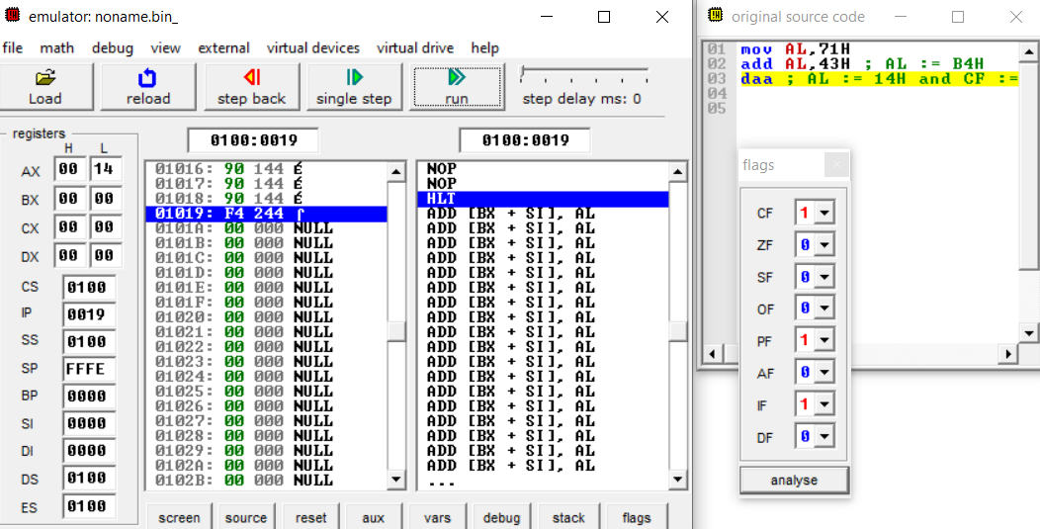

1. **DAS:**

MOV AL,71H

SUB AL,43H ; AL: 2EH

DAS ; AL: 28H

**Output:**

